Updated information from the Government and Public Health England

Symptoms
The most common symptoms of coronavirus (COVID-19) are recent onset of:
- new continuous cough, and/or high temperature
- high temperature
For most people, coronavirus (COVID-19) will be a mild infection
Stay at home advice
This guidance is for people with confirmed or possible coronavirus (COVID-19) infection who are required to stay at home.
The main messages are:
- if you have symptoms of coronavirus infection (COVID-19), however mild, stay at home and do not leave your house for 7 days from when your symptoms started. (See Ending Isolation section below for more information)
- this action will help protect others in your community whilst you are infectious
- plan ahead and ask others for help to ensure that you can successfully stay at home
- ask your employer, friends and family to help you to get the things you need to stay at home
- stay at least 2 metres (about 3 steps) away from other people in your home whenever possible
- sleep alone, if that is possible
- wash your hands regularly for 20 seconds, each time using soap and water
- stay away from vulnerable individuals such as the elderly and those with underlying health conditions as much as possible
- you do not need to call NHS111 to go into self-isolation. If your symptoms worsen during home isolation or are no better after 7 days contact NHS 111 online. If you have no internet access, you should call NHS 111. For a medical emergency dial 999

Who this guidance is for
This advice is intended for people with symptoms of coronavirus (COVID-19), including those with a diagnosis of coronavirus (COVID-19) infection, who must remain at home until they are well.
Will I be tested if I think I have COVID-19
We will not be testing those self-isolating with mild symptoms. The following advice is designed to help people prevent the spread.

Why has the advice on self-isolation changed from 14 days to 7 days
The 14 day period is for those who have had exposure to a confirmed case but have not shown symptoms. The 14 days represents the potential incubation period (the time it takes for symptoms to show if you have been infected).
Most people will no longer be likely to transmit the virus 7 days after the onset of symptoms. You do not need to call NHS111 to go into self-isolation. If your symptoms persist past 7 days you should contact NHS 111 online at 111.nhs.uk. If you have no internet access, you should call NHS 111.

Why staying at home is very important
It is very important that you stay at home whilst you have coronavirus (COVID-19). This will help to protect your friends, colleagues and the wider community and will help control the spread of the virus.
We realise that staying at home may be difficult or frustrating, but there are things that you can do to help make it easier. These include:
- Plan ahead and think about what you will need in order to be able to stay at home for the full 7 days.
- Talk to your employer, friends and family to ask for their help to access the things you will need in order to successfully stay at home.
- Think about and plan how you can get access to food and other supplies such as medications that you will need during this period.
- Ask friends or family to drop off anything you need or order supplies online, but make sure these are left outside your home for you to collect.
- Make sure that you keep in touch with friends and family over the phone or through social media.
- Think about things you can do during your time at home. People who have successfully completed a period of staying at home have kept themselves busy with activities such as cooking, reading, online learning and watching films.
- When you are feeling better, remember that physical exercise can be good for your wellbeing. Look for online classes or courses that can help you take light exercise in your home.

While you are staying at home, make sure you do the following things:
Stay at home
You should remain in your home. Do not go to work, school, or public areas, and do not use public transport or taxis. You cannot go for a walk.
You will need to ask friends or relatives if you require help with buying groceries, other shopping or picking up medication. Alternatively, you can order medication by phone or online. You can also order your shopping online. Make sure you tell delivery drivers to leave items outside for collection if you order online. The delivery driver should not come into your home.
At home, try as best you can to separate yourself from the people you live with
You should aim to stay in a well-ventilated room with a window that can be opened. Try to keep the window open as much as possible to enable ventilation and air flow as this will help to keep clean air moving through your room.
Try to separate yourself from other people in your home and keep the door closed. If you cannot stay in a separate room aim to keep 2 metres (3 steps) away from the other people in your house. We understand that this can be particularly difficult for parents of small children, people with other caring responsibilities or those living in studio apartments, for example.
Further advice can be found below. Try to keep yourself separated from other people as much as possible, and make sure everyone regularly follows the steps in this document (washing your hands, not touching your face, cleaning surfaces etc.).
Use your own toothbrushes, eating and drinking utensils (including cups and glasses in the bathroom and bedroom), dishes, drinks, towels, washcloths or bedlinen.
If you have your own garden it is fine to use it as long as you keep two metres away from other members of your household. If possible they should use the outside area separately.
Use of shared spaces if you live with others
Minimise the time you spend in shared spaces such as kitchens, bathrooms and sitting areas as much as possible and keep shared spaces well ventilated.
Aim to keep 2 metres (3 steps) away from people you live with and sleep in a different bed where possible. If you can use a separate bathroom from the rest of the household. Make sure you use separate towels from other people in your house, both for drying yourself after bathing or showering and for hand hygiene purposes. Ask your family or the people you live with to remember to use their own towels.
If you do share toilet and bathroom, it is important that you clean them after you have used them every time (e.g. wiping surfaces you have come in contact with). Another tip is to consider drawing up a rota for bathing, with you using the facilities last, before thoroughly cleaning the bath, sink and toilet yourself.
If you share a kitchen with others, avoid using it whilst others are present. Take your meals back to your room to eat. If you have one, use a dishwasher to clean and dry your used crockery and cutlery. If this is not possible, wash them using your usual washing up liquid and warm water and dry them thoroughly, remembering to use a separate tea towel.
We understand that it will be difficult for some people to separate themselves from others at home. You should do your very best to follow this guidance and everyone in your household should regularly wash their hands, avoid touching their face and clean frequently touched surfaces.
What if I am living alone with my children?
Keep following this advice to the best of your ability however we are aware that not all these measures will be possible.
What we have seen so far is that children with COVID-19 appear to be less severely affected. It is nevertheless important to do your best to follow this guidance.
If your child develops symptoms, they need to stay at home for 7 days from the onset of their symptoms.
What if I live with an older, vulnerable or pregnant person?
If you provide care to an elderly, vulnerable or pregnant person keep following this advice to the best of your ability.
However, we are aware that not all these measures will be possible.
.Cleaning and disposal of waste
When cleaning you should use your usual household products, like detergents and bleach as these will be very effective at getting rid of the virus on surfaces. Clean frequently touched surfaces.
Personal waste (e.g. used tissues) and disposable cleaning cloths can be stored securely within disposable rubbish bags. These bags should be placed into another bag, tied securely and kept separate from other waste within your own room. This should be put aside for at least 72 hours before being put in your usual external household waste bin.
Other household waste can be disposed of as normal.
Laundry
Do not shake dirty laundry; this minimises the possibility of dispersing virus through the air.
Wash items as appropriate in accordance with the manufacturer’s instructions.. Dirty laundry that has been in contact with an ill person can be washed with other people’s items.
If you do not have a washing machine you can then take your laundry to a launderette after your isolation period has ended.
If you do not have a washing machine wait a further 72 hours after your 7 day isolation period has ended when you can then take your laundry to a public laundromat.
What you can do to help yourself get better
Drink water to keep yourself hydrated; you should drink enough during the day so your urine (pee) is a pale clear colour. You can use over the counter medications, such as paracetamol, to help with some of your symptoms. Use these according to the instructions on the packet/label and do not exceed the recommended dose.
If you need to seek medical advice
Seek prompt medical attention if your illness is worsening. If it’s not an emergency, contact NHS 111 online at 111.nhs.uk. If you have no internet access, you should call NHS 111. If it is an emergency and you need to call an ambulance, dial 999 and inform the call handler or operator that you have coronavirus (COVID-19).
All routine medical and dental appointments should usually be cancelled whilst you are sick and staying at home. If you are concerned or have been asked to attend in person within the period you are home isolating, discuss this with your medical contact first (e.g. your GP, local hospital or outpatient service), using the number they have provided. If your concerns are related to COVID-19 contact NHS 111 online at 111.nhs.uk. If you have no internet access, you should call NHS 111.
Wash your hands often
Cleaning your hands frequently throughout the day by washing with soap and water for 20 seconds or using hand sanitiser will help protect you and the people you live with. This step is one of the most effective ways of reducing the risk of infection to you and to other people.
Cover your coughs and sneezes
Cover your mouth and nose with disposable tissues when you cough or sneeze.
If you have a carer they should take care to use disposable tissues to wipe away any mucus or phlegm after you have sneezed or coughed.
Dispose of tissues into a disposable rubbish bag and immediately wash your hands with soap and water or use a hand sanitiser.
Facemasks
We do not recommend the use of facemasks as an effective means of preventing the spread of infection. Facemasks play an important role in clinical settings, such as hospitals, but there’s very little evidence of benefit from their use outside of these settings. However if you receive external care you may be asked to wear a mask to minimise the risk to your carer.
Do not have visitors in your home
Do not invite or allow social visitors, such as friends and family, to enter your home. If you want to speak to someone who is not a member of your household, use the phone or social media.

If you have pets in the household
At present, there is no evidence that companion animals/pets such as dogs and cats can be infected with coronavirus (COVID-19).
Looking after your wellbeing whilst staying at home
We know that staying at home for a prolonged period of time can be difficult, frustrating and lonely for some people and that you may feel low. It’s important to remember to take care of your mind as well as your body and to get support if and when you need it. Stay in touch with family and friends over the phone or on social media. There are also sources of support and information that can help.
https://www.nhs.uk/oneyou/every-mind-matters/
Think about things you can do during your time at home. People who have successfully completed a period of staying at home have kept themselves busy with activities such as cooking, reading, online learning and watching films. If you feel well enough you can take part in light exercise within your home or garden.
Ending self-isolation
You should remain at home until 7 days after the onset of your symptoms. After 7 days, if you feel better and no longer have a high temperature, you can return to your normal routine. If you have not had any signs of improvement and have not already sought medical advice, you should contact NHS 111 online at 111.nhs.uk. If you have no internet access, you should call NHS 111.
Cough may persist for several weeks in some people, despite the coronavirus infection having cleared. A persistent cough alone does not mean you must continue to self-isolate for more than 7 days.

Published 12 March 2020 on https://www.gov.uk/guidance/coronavirus-covid-19-information-for-the-public

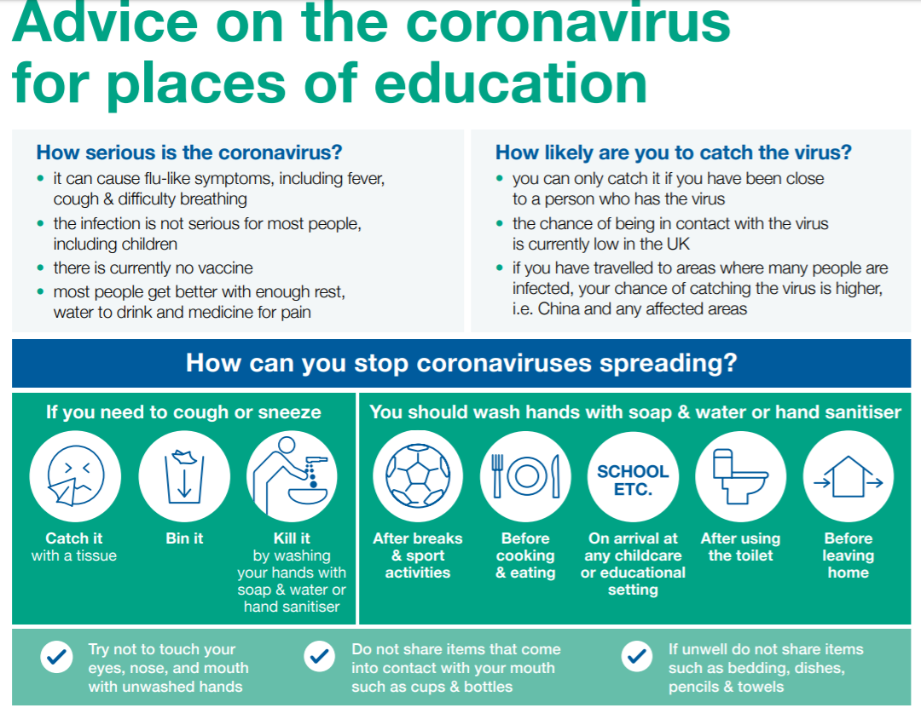

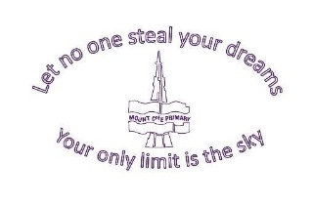

13.3.2020
Dear parents/carers,
Following yesterday’s Government meeting about the coronavirus outbreak, we write to update you on recent advice to the public and schools.
Advice from the Department for Education and Public Health England continues to be that schools remain open. It is thought that closing schools at this stage would not have any impact on containing the spread of the virus. Current advice is that if anyone suspects they have coronavirus or is confirmed as having coronavirus, they should self-isolate for 7 days. Attached is the latest information from the Government on how to take care of your family and others during this time.
The current stage of the Government’s plan is classed as the “delay” stage and it is predicted that the peak of the outbreak will be in May or June. Currently, children have not been identified as being at high risk. It is the elderly or people with pre-existing health conditions who are most at risk.
If you feel concerned about yourself or someone in your family, then please phone NHS 111 or visit www.nhs.uk
DO NOT visit your GP or visit a medical centre as this could put vulnerable people at risk.
We will continue to keep parents up to date with our school situation. As you will be aware from the text message sent out to parents today, we have two children and a member of staff that have been in contact with individuals who have been asked to self-isolate as a precaution. I must emphasise that these cases have not been confirmed as coronavirus and the children and member of staff have not shown any symptoms at present. They are following the latest guidance from Public Health England to self-isolate for 7 days as a precaution.
The health and well-being of our children and community continue to be a priority and at the forefront of our daily practice. We would like to reassure parents that, although current advice is that schools do not need to close if a confirmed case should occur, we would of course inform parents immediately.
Public Health England and the Department for Education expect children to attend school. Whilst we understand that this is an anxious time for many parents, absences due to worry about unconfirmed cases cannot be authorised.
This information is intended to inform parents rather than cause worry and we would like to remind parents that we are still in the season of colds and many other winter ailments which are not linked to coronavirus.
If you have any queries, please do not hesitate to speak to myself or any member of staff.
Thank you for your continued support.
Kind Regards,

Mrs C Kent
Headteacher

